Journal of Advanced Research in Instrumentation and Control Engineering
Vol 12 No 3&4 (2025)
Research Article

Optimizing Food Ordering App Data Analysis Using Support Vector Machines (SVM): A Machine Learning Approach for Customer Behaviour Prediction and Sales Forecasting
Javika Mughdan*¹, Sumit walia²
¹Student Research & Punjab College of Technical Education
²Student Researcher & Punjab College of Technical Education

Email ID: mughdanjavika@gmail.com
Orcid ID: 0009-0004-7730-3365
Date of Receiving: 17th August 2025
Date of Acceptance: 27th September 2025

.
Abstract
Robust growth in food delivery services creates a demand for a restless analytical instrument. The present research study applied SVM for the analysis of data obtained from the food ordering application, mainly on customer behaviour prediction and sales forecasting. SVM has been trained on transaction data from the past, user preference, and external sly factors, such as weather and time, in order to appropriately glean ordering behaviour. This allows businesses to predict customer response proactively and therefore protect business efficiency as well as profitability. The performance of SVM methodology has been evaluated against other machine learning algorithms with respect to their capability to capture non-linear relationships in food-ordering data. The results obtained ratify the potential for SVM in improving recommendation systems through providing accurate predictions for user preferences, thereby increasing their rate of order and turnover. In relation to the forecasting of demand, this creates another factor of great importance in resource management since it minimizes wastage and optimizes the logistics of deliveries. Beyond mere foretelling, SVM's predictive capabilities help in customer retention through various promotional attempts to target different market segments. By learning consumer behaviour, a business can tailor its services, breeding customer loyalty and enhancing customer lifetime value. The present research builds SVM as a rugged application in food delivery for data-driven decision-making leading to profitability maximization and improved customer service. The findings in this work highlight the SVM as a useful tool, providing actionable insights and competitive advantages in the fast-paced food delivery context.

Keywords: Food Ordering, Machine Learning, Support Vector Machines, Customer Behavior, Sales Forecasting, Predictive Analytics, Recommendation Systems, Demand Forecasting, Customer Retention.

- Introduction
The online food delivery sector has seen a lot of growth recently, more so than ever before, because of the increased demand for convenience and the increased pace of national digitalisation. Such growth has produced a massive amount of data: from customer preferences to ordering patterns as well as other external forces impacting consumption. It is important to refine this data so that any business can optimise for operations, improve on user experience, and maximise profits. Being able to foresee customer behaviour and effectively predict future orders is perhaps one of the most fundamental problems facing this growing industry. Though of value, more traditional statistical approaches may at times fail to accurately depict complex, non-linear relationships within large and complicated datasets. As such, obviously, they have given way to other more efficient advanced methods of problem-solving. A prominent example of such a method would be support vector machines [1-3].
SVMs have gained widespread recognition for their potential to deal with high-dimensional data and to fit non-linear boundaries. This study will explore the basic support vector machine techniques to solve key business problems in the food delivery industry, covering three primary areas of concern: customer segmentation, demand forecast, and order recommendation. First of all, customer segmentation is essential to promote targeted marketing and personalised service [4]. SVMs can be comfortably clustered into customer segments based on habits regarding food ordering, diet preferences, and demographic features, enabling businesses to conduct promotions and make offers specific to segments. Second, demand forecasting is another important problem that requires the SVM method for promoting not only food ordering but also related logistics other than operational costs. Historical ordering data, teamed with external factors such as the weather and time of day, may be analysed by SVMs to predict order volumes in an effort to reduce unrequired waste or, for example, convince people of the necessity to dispatch food products on time [5-7]. Finally, order recommendations for enhanced customer engagement and sales are important to boost order frequency and spend. SVMs can be of great use here to analyse user needs/past history with regard to orders, hence matching them with appealing recommendations. This research will prove how SVMs can extract valuable insights using data from a food ordering app and provide a data-driven approach for optimising operational efficiency and improving customer experience. By studying the use of SVMs in customer segmentation, demand forecasting, and order recommendation, this study aims to supplement the growing body of knowledge on machine learning applications for food delivery, together with providing managers many practical implications to try to gain a competitive edge [8-11].

Literature Review:
In the wake of a surge of interest regarding the modelled applications of machine learning in food delivery, existing research has documented several methods orientated toward predictive analytics. For example, decision trees have been reviewed due to their transparency in distinguishing which features dictate ordering patterns. In contrast, deep learning architectures of neural networks have been used to capture complex temporal dependencies in sales forecasts and customer behaviour. Clustering techniques such as k-means have also been employed for customer segmentation, enabling targeted marketing strategies toward distinct sets of users [5].
Among these methodologies, Support Vector Machines (SVMs) offer very promising alternatives, particularly from both classification and regression perspectives. SVMs perform exceptionally well when applied to high-dimensional and non-linear data, such as that generated by food-ordering apps, which usually involve diverse user preferences and complex ordering dynamics. Previous research has found SVMs useful in solving practical problems like customer segmentation based on purchasing behaviours, sales trend analysis in retail environments, and fraud detection in online transactions. Such studies demonstrate the capability of SVMs to detect complex patterns and make accurate predictions [6].
However, prior research has largely neglected the specific application of SVMs to food ordering app data. While existing insights provide a general perspective on SVM utilisation in related semi-empirical domains, little work has focused on designing and refining SVM models for food delivery platforms. This research aims to fill this gap by exploring the applicability of SVMs in predicting customer behaviour, demand forecasting, and recommendation systems for food ordering applications [7].
- Methodology
This research employs a quantitative approach, leveraging machine learning techniques to analyse food ordering app data. The methodology is structured into three primary phases: data collection, data preprocessing, and SVM implementation, followed by model evaluation.
3.1 Data Collection:
The foundation of this study lies in the acquisition of a comprehensive dataset from a prominent food ordering platform. This dataset encompasses:
Historical Order Data: Detailed transaction records, including order dates, times, items ordered, order values, delivery locations, and payment methods. This data serves as the primary source for understanding customer ordering patterns.
Customer Demographics and Behaviour: User profiles containing demographic information (age, gender, location), app usage frequency, order history, preferred cuisines, and ratings. This data facilitates customer segmentation and behavioural analysis.
External Factors: Environmental and promotional variables that may influence ordering behaviour, such as:
Weather Data: Temperature, precipitation, and weather conditions, obtained from reliable meteorological sources.
Time of Day and Day of Week: Categorical variables representing the time of order placement and the corresponding day of the week.
Promotional Information: Details of discounts, offers, and marketing campaigns, including their duration and target audience.
3.2 Data Preprocessing:
Raw data undergoes rigorous preprocessing to ensure its quality and suitability for machine learning analysis (Figure 1-3):
· Handling Missing Values and Outliers: Techniques such as imputation (mean, median, or mode) and outlier detection (using Z-scores or IQR) are employed to address data inconsistencies and improve model robustness.
· Feature Selection and Normalisation: Relevant features are selected based on their potential impact on predictive accuracy. Feature normalisation (e.g., min-max scaling or standardisation) is applied to scale numerical features to a uniform range, preventing bias due to differing feature magnitudes.
· Splitting the Dataset: The pre-processed dataset is partitioned into training and testing sets. The training set is used to train the SVM model, while the testing set is reserved for evaluating its performance on unseen data. A typical split ratio of 70:30 or 80:20 is used.
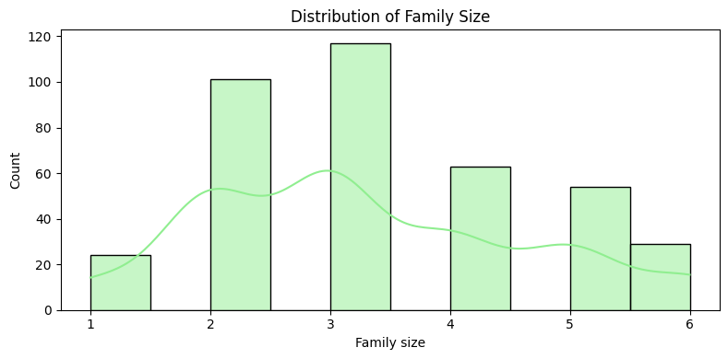
Figure 1 APPs used by families
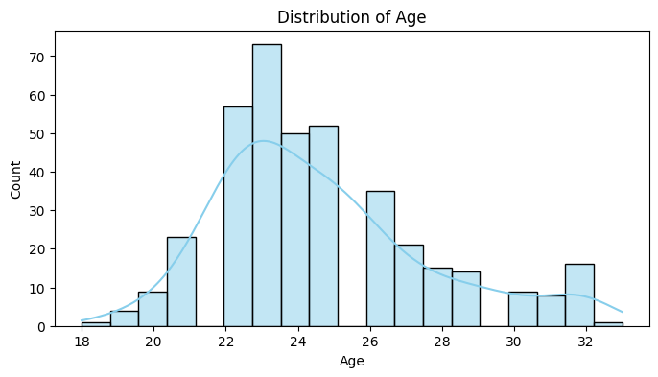
Figure 2 Apps used according to age
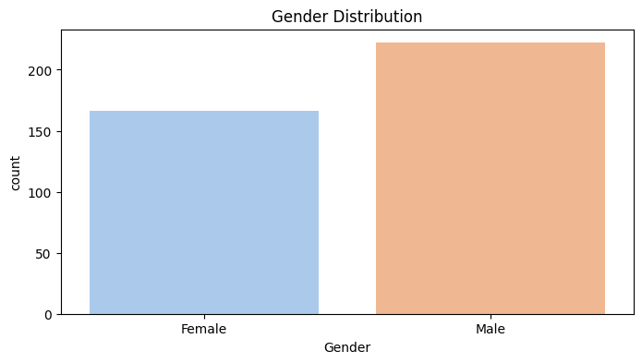
Figure 3 Apps used by Males and Females
3.3 SVM Implementation:
The core of this research involves the implementation of SVM models for two primary tasks: customer segmentation and sales forecasting (Table 1-2).
SVM for Classification of Customer Segments:
- SVM classification is used to categorise customers into distinct segments based on their ordering behaviour (e.g., frequent, occasional, or new users).
- Features such as order frequency, average order value, and preferred cuisines are used as input variables.
- The SVM model is trained to learn the decision boundaries that separate different customer segments.
SVM Regression for Sales Forecasting:
- SVM regression is employed to predict future sales trends based on historical order data and external factors.
- Time-series features, such as past order volumes and seasonal patterns, are incorporated into the model.
- The SVM model is trained to learn the relationships between input features and future sales.

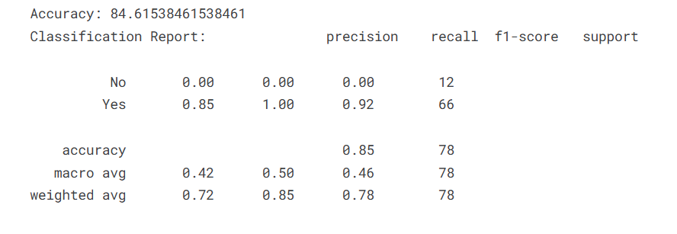
Table 1 Regression Results of the model
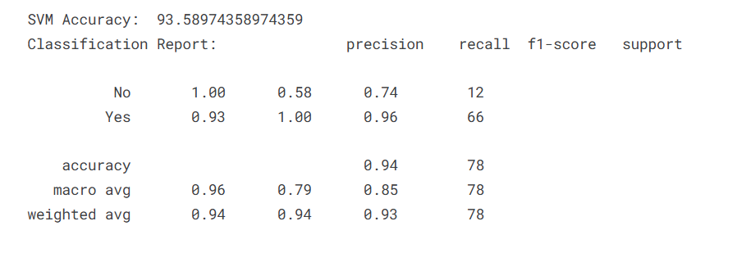
Table 2 SVM model Accuracy and Matrix Score
Model Evaluation:
- The performance of the SVM models is evaluated using a range of metrics, including:
  - Accuracy: The proportion of correctly classified instances.
  - Precision: The proportion of correctly predicted positive instances.
  - Recall: The proportion of actual positive instances that are correctly predicted.
  - F1-score: The harmonic mean of precision and recall.
- Cross-validation techniques are used to ensure the model generalises well.
- Results and Discussion
The results of this study are presented in a comparative analysis, evaluating the performance of SVM against other machine learning models; specifically, Decision Trees and Neural Networks are shown in figures 4-6.
- Performance Comparison:
  - The accuracy, precision, recall, and F1-score of the SVM classification model are compared with those of Decision Tree and Neural Network classifiers.
  - The MSE, RMSE, and MAE values for the SVM regression model are compared to those of competing regression models.
  - This comparison highlights the strengths and weaknesses of each model in the context of food ordering app data.
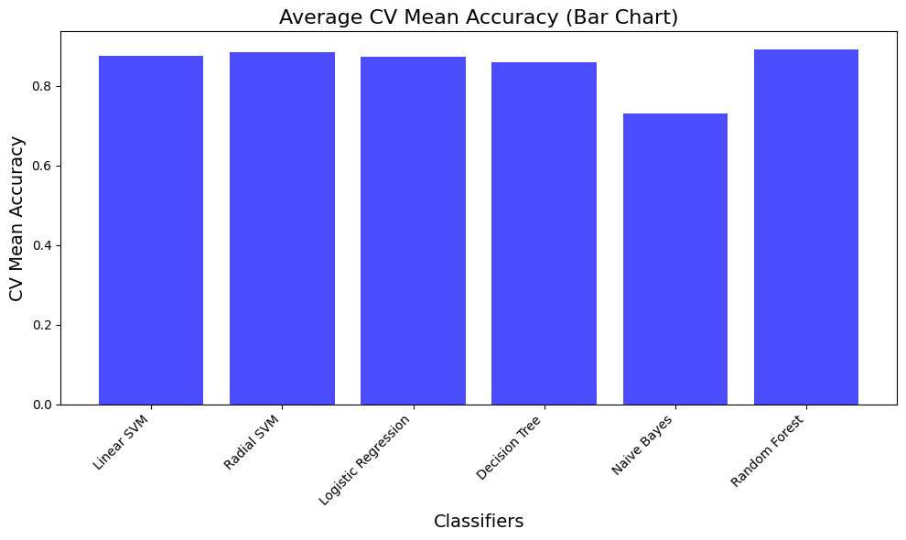
Figure 4 Comparision in Multiple models accuracy
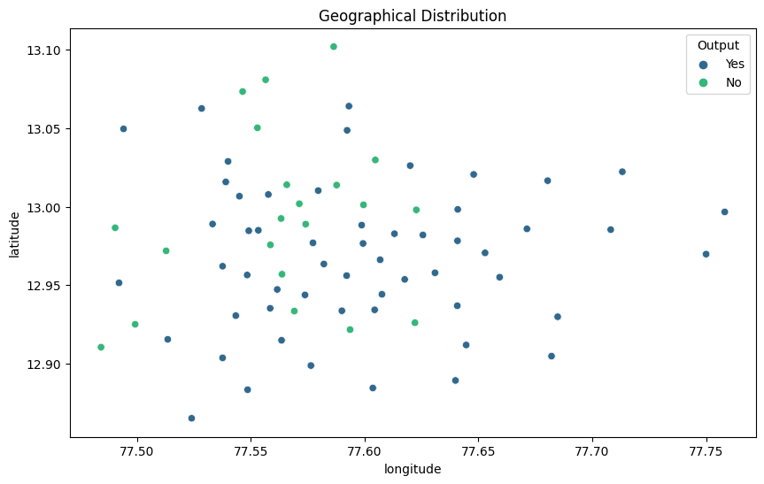
Figure 5 Analysis of the Users
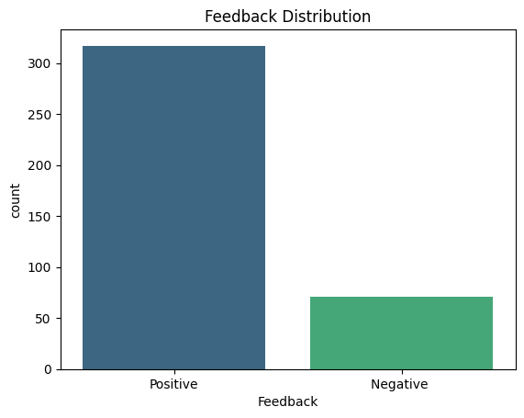
Figure 6 Feedback from the users

- Conclusion
This study effectively demonstrates the utility of Support Vector Machines (SVM) as a robust tool for analysing food ordering app data. The findings highlight SVM's capacity to deliver improved customer behaviour prediction and more accurate sales forecasting compared to other methodologies. The ability of SVM to handle complex, non-linear patterns within the data proves particularly advantageous in this context.
The practical implications of this research are significant, offering actionable insights for businesses operating within the food delivery sector. The enhanced predictive capabilities of SVM enable more targeted marketing strategies, optimised inventory management, and improved customer retention.
Looking forward, future research directions could explore the potential of hybrid models. Specifically, integrating SVM with deep learning techniques holds promise for further enhancing predictive accuracy. Deep learning models, with their ability to capture intricate temporal dependencies and learn hierarchical representations, could complement the strengths of SVM in handling complex data patterns. A hybrid approach may yield even more refined predictions, leading to further improvements in operational efficiency and customer experience within the food delivery industry. This exploration into hybrid models represents a valuable avenue for advancing the application of machine learning in this rapidly evolving domain.
References
- Ghosh S, Dasgupta A, Swetapadma A. A study on support vector machine based linear and non-linear pattern classification. In2019 International conference on intelligent sustainable systems (ICISS) 2019 Feb 21 (pp. 24-28). IEEE.
- Lu CJ. Sales forecasting of computer products based on variable selection scheme and support vector regression. Neurocomputing. 2014 Mar 27;128:491-9.
- Tabianan K, Velu S, Ravi V. K-means clustering approach for intelligent customer segmentation using customer purchase behavior data. Sustainability. 2022 Jun 13;14(12):7243.
- Venkatesh R, Keerthi CV, Harshitha A, Deepika KS, Rajyalakshmi E. Customer segmentation using support vector machine. COMPUTATIONAL INTELLIGENCE AND NETWORK SECURITY. 2023 Apr 28;2724(1):020008.
- Gao C, Zhang F, Zhou Y, Feng R, Ru Q, Bian K, He R, Sun Z. Applying deep learning based probabilistic forecasting to food preparation time for on-demand delivery service. InProceedings of the 28th ACM SIGKDD conference on knowledge discovery and data mining 2022 Aug 14 (pp. 2924-2934).
- Gao C, Zhang F, Zhou Y, Feng R, Ru Q, Bian K, He R, Sun Z. Applying deep learning based probabilistic forecasting to food preparation time for on-demand delivery service. InProceedings of the 28th ACM SIGKDD conference on knowledge discovery and data mining 2022 Aug 14 (pp. 2924-2934).
- Kumar S, Gunjan VK, Ansari MD, Pathak R. Credit card fraud detection using support vector machine. InProceedings of the 2nd International Conference on Recent Trends in Machine Learning, IoT, Smart Cities and Applications: ICMISC 2021 2022 Jan 10 (pp. 27-37). Singapore: Springer Nature Singapore.
- Boser BE, Guyon IM, Vapnik VN. A training algorithm for optimal margin classifiers. InProceedings of the fifth annual workshop on Computational learning theory 1992 Jul 1 (pp. 144-152).
- P Suthaharan S. Support vector machine. InMachine learning models and algorithms for big data classification: thinking with examples for effective learning 2016 Jan (pp. 207-235). Boston, MA: Springer US.
- Pisner DA, Schnyer DM. Support vector machine. InMachine learning 2020 Jan 1 (pp. 101-121). Academic Press.
- Mining WI. Data mining: Concepts and techniques. Morgan Kaufinann. 2006;10(559-569):4.
- Ruppert D. The elements of statistical learning: data mining, inference, and prediction.
- Kohavi R. A study of cross-validation and bootstrap for accuracy estimation and model selection. InIjcai 1995 Aug 20 (Vol. 14, No. 2, pp. 1137-1145).

